Center of Gravity Analysis
Student’s Name
Institutional Affiliation

Center of Gravity Analysis

Introduction:

Logistics helps to improve the availability of the perfect location for a business perspective to utilize it more perfectly. We have a scenario with a situation in which there is a direct supplier, and then we have to find a place between them to reduce the cost which is being spent on the trucking per mile. That one place is called logistics center (Mangan et al., 2016).

Logistics is the science of management, technical activities, maintaining resources to support objectives and plan of execution. The provisioning management takes into thought each facility that has a control on price. It plays a crucial role in creating the merchandise adapt to client necessities. conjointly it involves economic integration of suppliers, makers, warehouses, and stores and encompasses the firms’ activities at several levels, from the strategic level through the military science to the operational level

Summary of Results:
When there is no center created and we have the usual communication between suppliers and stores, the cost is maximum and the trucking is direct so there is direct communication between stores and suppliers

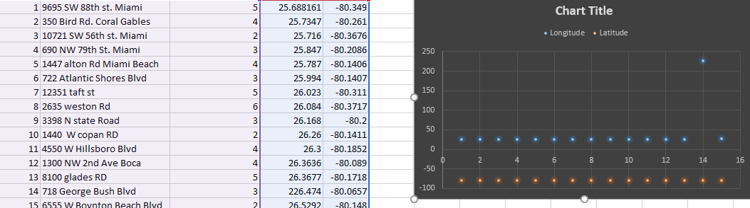
When we create a point or a center between suppliers and stores. It converges the points between both sources or both connections. The above point indicates the supplier and the lower one is for the stores and the converged points between them indicates the logistic center having a lesser cost for trucking from all the suppliers to all the stores.
It indicates that the number of stores is less and if we have all the suppliers directly connected to the stores the indicated costs will be so much high as compared to the cost when we create a central place where all the trucks converge and then the supply is supplied to the stores
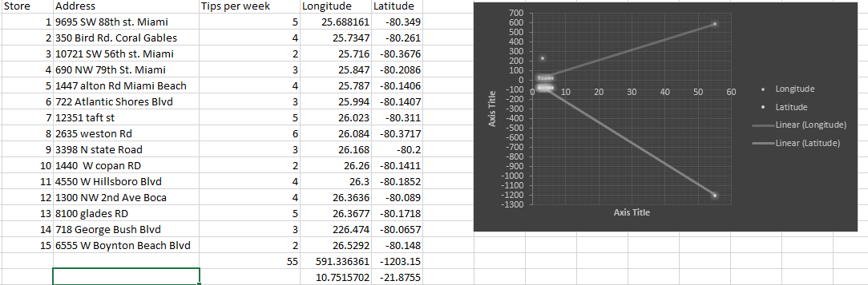

Recommendation:
There are two possible recommendations for the PK village either we have to create the point between the two sources of the supply or we have to reduce the distance. When we notify both A and B then we have to consider the place where if we place central point it will be suitable for the reduce of trucking cost and other related elements (Christopher, 2016).
Point A is more suitable because it costs less than option B. The Price Option A offers $11.50 and Option B offers $12.25. So, for the sake of less cost we have to follow the concept of having option A and we have to consider the buildings too. There are three buildings which can be considered for the logistics center. So, for the sake of less cost and most appropriate building which can be approachable from any side is very suitable for that.
so we are having the building.
So, the best approach that the for choosing A and B identified by the realtors is that we have to choose the value of cost and the location at the same time.

Reference:
Mangan, J., Lalwani, C., & Lalwani, C. L. (2016). Global logistics and supply chain management. John Wiley & Sons.
Christopher, M. (2016). Logistics & supply chain management. Pearson UK.

